
Gallery Hire Proposal Form
for Galleries 1.2 / 1.3 / 1.2 & 1.3
at the Herbert Art Gallery & Museum

Culture Coventry, Herbert Art Gallery & Museum, Jordan Well, Coventry CV1 5QP

Please let us know if you have any access requirements or need support filling in this form by emailing exhibitions@cvlife.co.uk

Please see our website www.theherbert.org for the next deadline to send in your Proposal Form.
This will usually be in January (for bookings April – September) and June (for bookings October – March).

Please tell us about your proposal for an exhibition.

Name of Exhibitor (Artist/Curator/Group/Organisation):

Contact name if different from above:

Email:

Telephone:

Social media/web links:

Address:

Please confirm that this person would be the main contact, including responsibility for Health & Safety ❑ Yes ❑ No

Is this a group exhibition? ❑ Yes ❑ No If Yes, number of artists in the group:

Exhibition
Please provide an outline of your exhibition, including information about themes, aims and outcomes (maximum 250 words):

Proposed nature, size and number of artworks (indicative estimate):

Technical
Please indicate what the installation of the exhibition would involve, such as installing artwork, audio visual, other. Please note, Culture Coventry cannot provide technician support but we can usually source this on behalf of Exhibitors if required. Payment for technician services would be the responsibility of the Exhibitor.

If you intend to install the work yourself, please tell us what experience you have of doing this:

Target audience
Who is your exhibition aimed at:

Marketing
Culture Coventry will support the marketing of your exhibition through our website, social media channels and newsletter. Please tell us about any marketing you would be doing yourself to bring audiences to the venue:

Images
Please supply up to 10 images of the artwork, or examples of similar proposed artwork, to support your application and for promotional purposes:

Image: 1 Artist/Artwork details:
Etc

Payment
*The current Licence Fee for our galleries is £120 a week for Gallery 1.2 or Gallery 1.3, or £180 a week for Galleries 1.2 & 1.3. There is a minimum hire period of two weeks.

LICENCE FEE PAYABLE | Amount  £
Number of weeks x weekly Licence Fee *£120 / *£180
(eg 2 weeks in Gallery 1.3 x £120 = £240)

If your application is successful, Coventry Culture will issue you with an invoice for the Licence Fee, and this will need to be paid in full before the booking can be confirmed. Please let us know if the invoice should be made out to someone other than the main contact and address given on the first page:

Please note that the Exhibitor is responsible for all their costs associated with the exhibition.

Dates
Please include your first and second choice of dates for your exhibition, including installation and deinstallation. Before completing this section, please view the Schedule below for the dates currently available.

First Choice Installation Date(s):
Exhibition Dates:
Deinstallation Date(s):

Second Choice Installation Date(s):
Exhibition Dates:
Deinstallation Date(s):

Invigilation
We normally expect the exhibition space to be open to the public during our opening hours:
Monday: CLOSED (Open for Bank Holiday Mondays)
Tuesday to Saturday: 10am – 4pm
Sunday: 12pm – 4pm
Culture Coventry will not provide invigilation of the exhibition. Subject to a risk assessment of the exhibition, it may be possible for the exhibition to be open without invigilation. However, the Exhibitor or their representative is normally required to invigilate the exhibition at all times during open hours.
Please tell us how the exhibition will be invigilated:

Events
Tell us about any events you are planning to support the exhibition, such as a private view or workshops (include a brief description, dates and times):

Cancellation Policy
The Licence Fee is paid in full on booking. We will issue part or full refunds based on the following:
At least 6 months’ notice of cancellation: 100% refund
3–6 months’ notice: 50% refund
Less than 3 months’ notice: 0% refund

Accessibility
Please tell us about any accessibility requirements you may have during your use of the space:

Queries
Please send any queries to: exhibitions@cvlife.co.uk

Signature: Date:

PLEASE RETURN THIS FORM IN EITHER A WORD DOCUMENT OR PDF TO:
exhibitions@cvlife.co.uk
Thank you

SCHEDULE

Gallery 1.2: Available 8 June – 27 September 2026
Gallery 1.3: Available 30 March – 27 September 2026
Gallery 1.2 and 1.3: Available 8 June – 27 September 2026

Booking Period | Dates  Please note: these dates need to include your install and deinstall days. | Gallery 1.2  Please put 1 for your first choice and 2 for your second choice. | Gallery 1.3  Please put 1 for your first choice and 2 for your second choice. | Gallery 1.2 & 1.3  Please put 1 for your first choice and 2 for your second choice.
11 | Mon 30 March –  Sun 12 April 2026 | Not Available |  | Not Available
12 | Mon 13 April –  Sun 26 April 2026 | Not Available |  | Not Available
13 | Mon 27 April –  Sun 10 May 2026 | Not Available |  | Not Available
14 | Mon 11 May –  Sun 24 May 2026 | Not Available |  | Not Available
15 | Mon 25 May –  Sun 7 June 2026 | Not Available |  | Not Available
16 | Mon 8 June –  Sun 21 June 2026
17 | Mon 22 June –  Sun 5 July 2026
18 | Mon 6 July –  Sun 19 July 2026
19 | Mon 20 July –  Sun 2 August 2026
20 | Mon 3 August –  Sun 16 August 2026
21 | Mon 17 August –  Sun 30 August 2026
22 | Mon 31 August –  Sun 13 September 2026
23 | Mon 14 September – Sun 27 September 2026
If booking for 4 weeks, please write 1 or 2 in 2 periods.
GALLERY 1.2 IMAGES

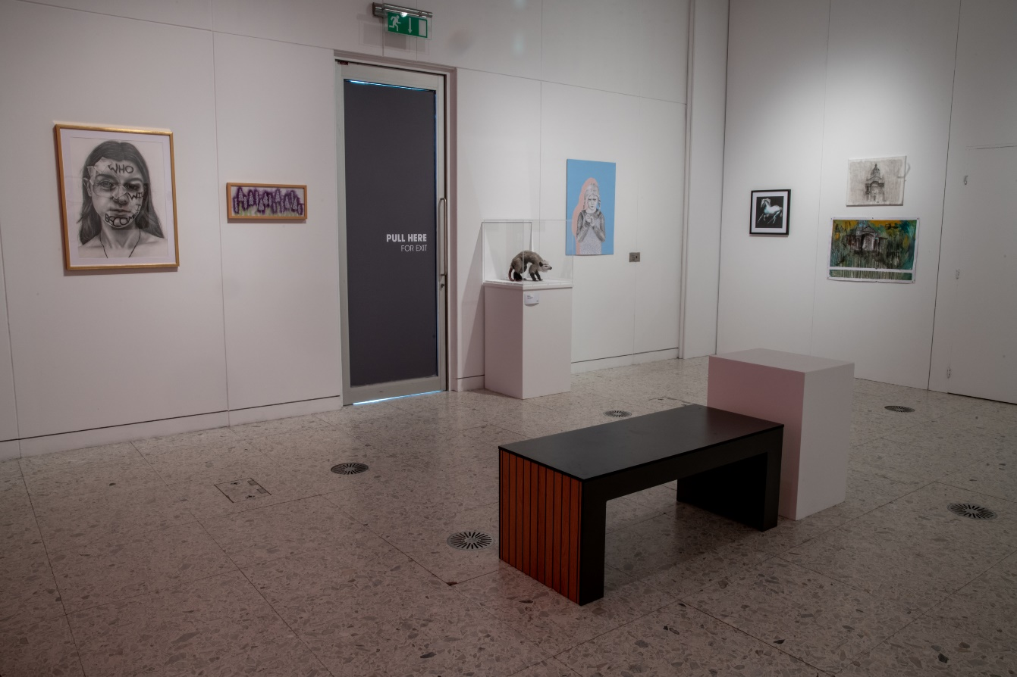
Showing the entry door and left side wall / Garry Jones Photography

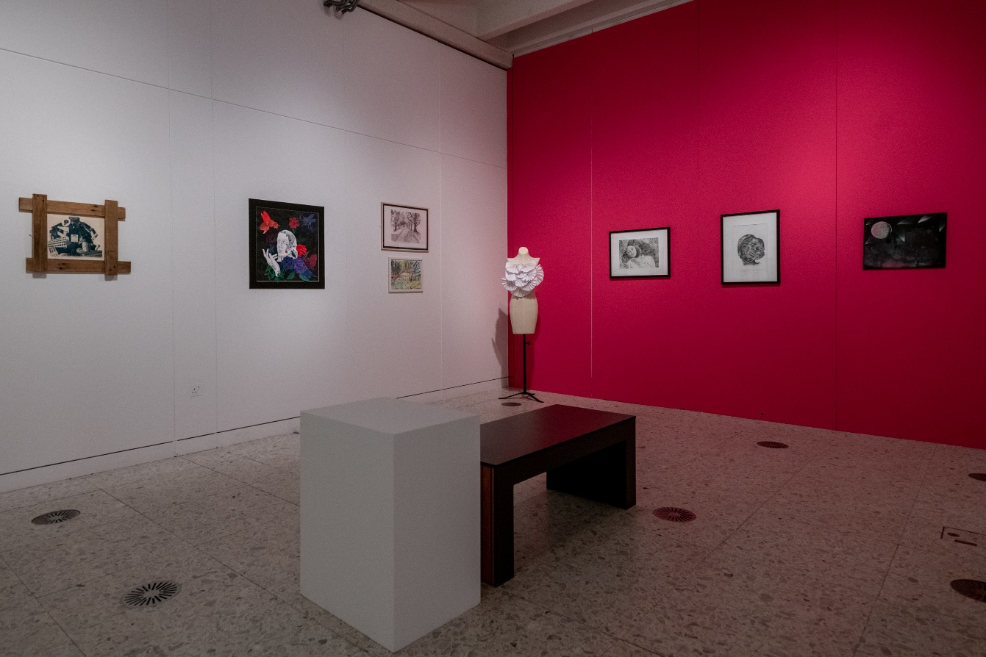
Showing the rear and right hand walls / Garry Jones Photography

GALLERY 1.3 IMAGES

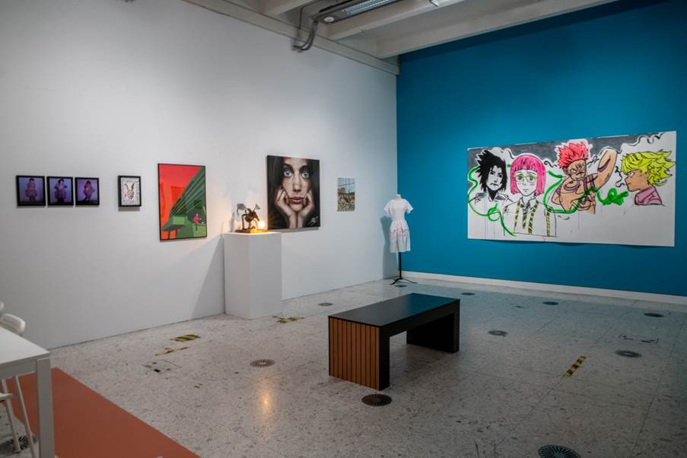
Showing the rear and right walls / Garry Jones Photography

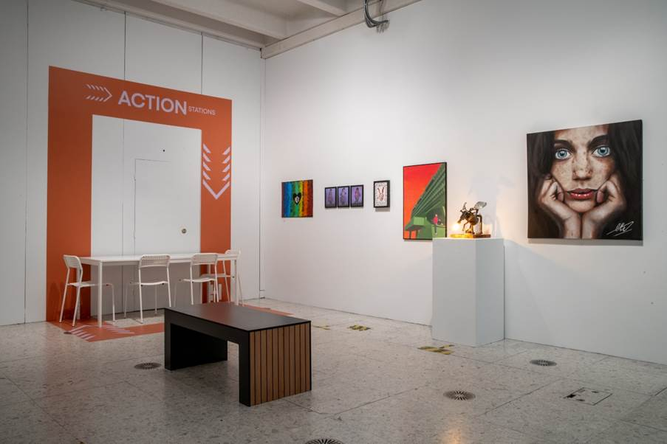Showing the rear and left walls (the door remains closed off) / Garry Jones Photography

