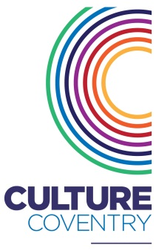
Current Opportunities

Position: Media Trainee
Pay: £1,847 (accrued over 45 days)
Job type: Part - time
Working hours: 5 hours Wednesday (another 5 hours to be negotiated
on appointment)

About the role
This is a fantastic opportunity to gain further experience in media production supporting the Creative Bridges programme which aims to support young people with learning difficulties into work, further learning or volunteering. Based within a museum setting at the Herbert Art Gallery & Museum in Coventry, the role will include both front facing and behind the scenes work. You will be given every opportunity to develop your skills and build your professional experience, to enable you to develop a career in media production or community work.

About the organisation
Culture Coventry Trust are one of Britain’s most exciting arts and heritage organisations. Its mission is to promote innovative and creative arts activities in ways which help to establish them as a significant part of people’s lives. The Trust supports a regular programme of exhibitions, educational workshops and performances and attracts over 700,000 visitors of all ages per year.

Since 2014, Herbert Media has delivered Creative Bridges, a programme to explore the impact of cultural and creative engagement on the successful transition to independent adult life for young people (16 – 25) with a learning disability; in particular focusing on their transition into employment or further training which will be key to achieving their independent living and life choices.

We are looking for candidates who:  - Are able to show a strong interest in film making and digital media production  - Can demonstrate strong communication skills, with the ability to adapt their communication style when handling a range of enquiries  - Can exhibit self-confidence in working with  small groups of diverse people  - Have good organisational skills, to enable methodical working in accordance with procedures  - Are able to work well independently as well as part of a team, using initiative and provide support to colleagues when required  - Are positive and flexible with a ‘can do’ attitude  - Can exhibit experience of either working  or volunteering in film production | With the guidance of and in consultation with members of the Herbert Media, the main areas of responsibility will be:  - Supporting the delivery and development of Creative Bridges as a part of the wider Culture Coventry service;  - Producing digital content to document and market our work  - Assist in the day-to-day operation of Herbert Media, in person, via email and phone and general administrative duties
Closing date for applications : 18 October 2019
Interviews to be held on : w/c 21 October 2019

