
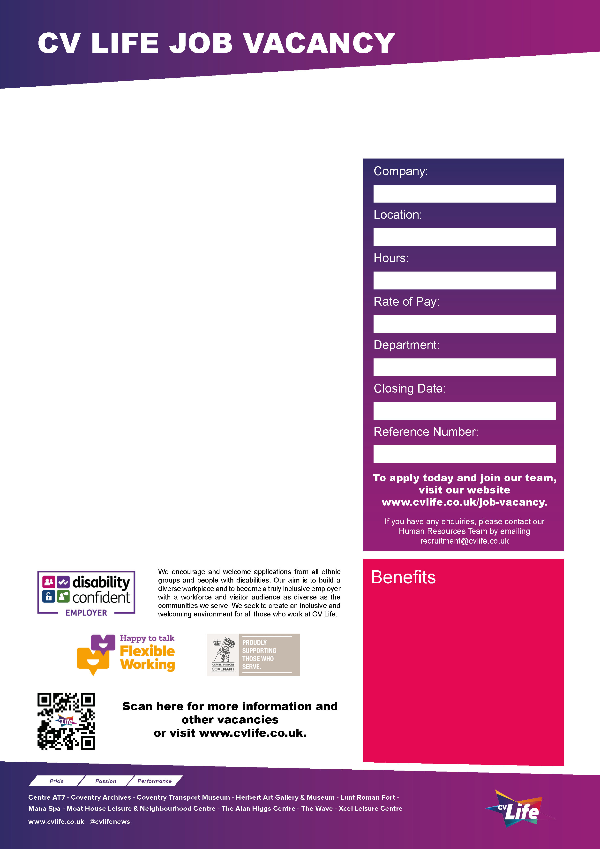
CV Life is committed to safeguarding and promoting the welfare of children and vulnerable adults and expects all staff and volunteers to share this commitment.

CV Life is seeking a Facilities Administrator to support the Head of Facilities Management in the effective delivery of facilities management services across all CV Life sites within Coventry.

The role involves proactively supporting the management of a diverse portfolio of premises, ensuring all facilities consistently meet the organisation’s high standards and operational requirements.

The Facilities Administrator provides essential administrative, compliance and financial support to ensure the smooth, safe and efficient operation of workplace facilities across all CV Life sites. The postholder plays a key role in maintaining accurate records, supporting maintenance activities, tracking compliance documentation and assisting the Head of Facilities Management with tasks across Leisure and Cultural venues.
Responsibilities include coordinating with external partners; the reactive and planned preventative maintenance activities across the portfolio, ensuring works are completed on schedule, overseeing urgent repairs within approved timescales and maintaining cost control in line with agreed budgets.

Working hours are 8am – 4pm however flexibility will be considered.

Facilities Administrator
- Great development opportunities
- FREE health and fitness membership* **
- FREE health and fitness membership for a family member or friend* **
- FREE onsite parking at most sites
- FREE training for applicable roles
- DISCOUNTS on various Centre activities*
- FREE entry to venues*
- Access to our Employee Benefits platform

( **The two benefits combined can be worth £1000!)
(*not applicable to casual workers)

CCT095
24th July 2026
Facilities
£24655.40 per annum

37
Multi Site
Culture Coventry Trust

