
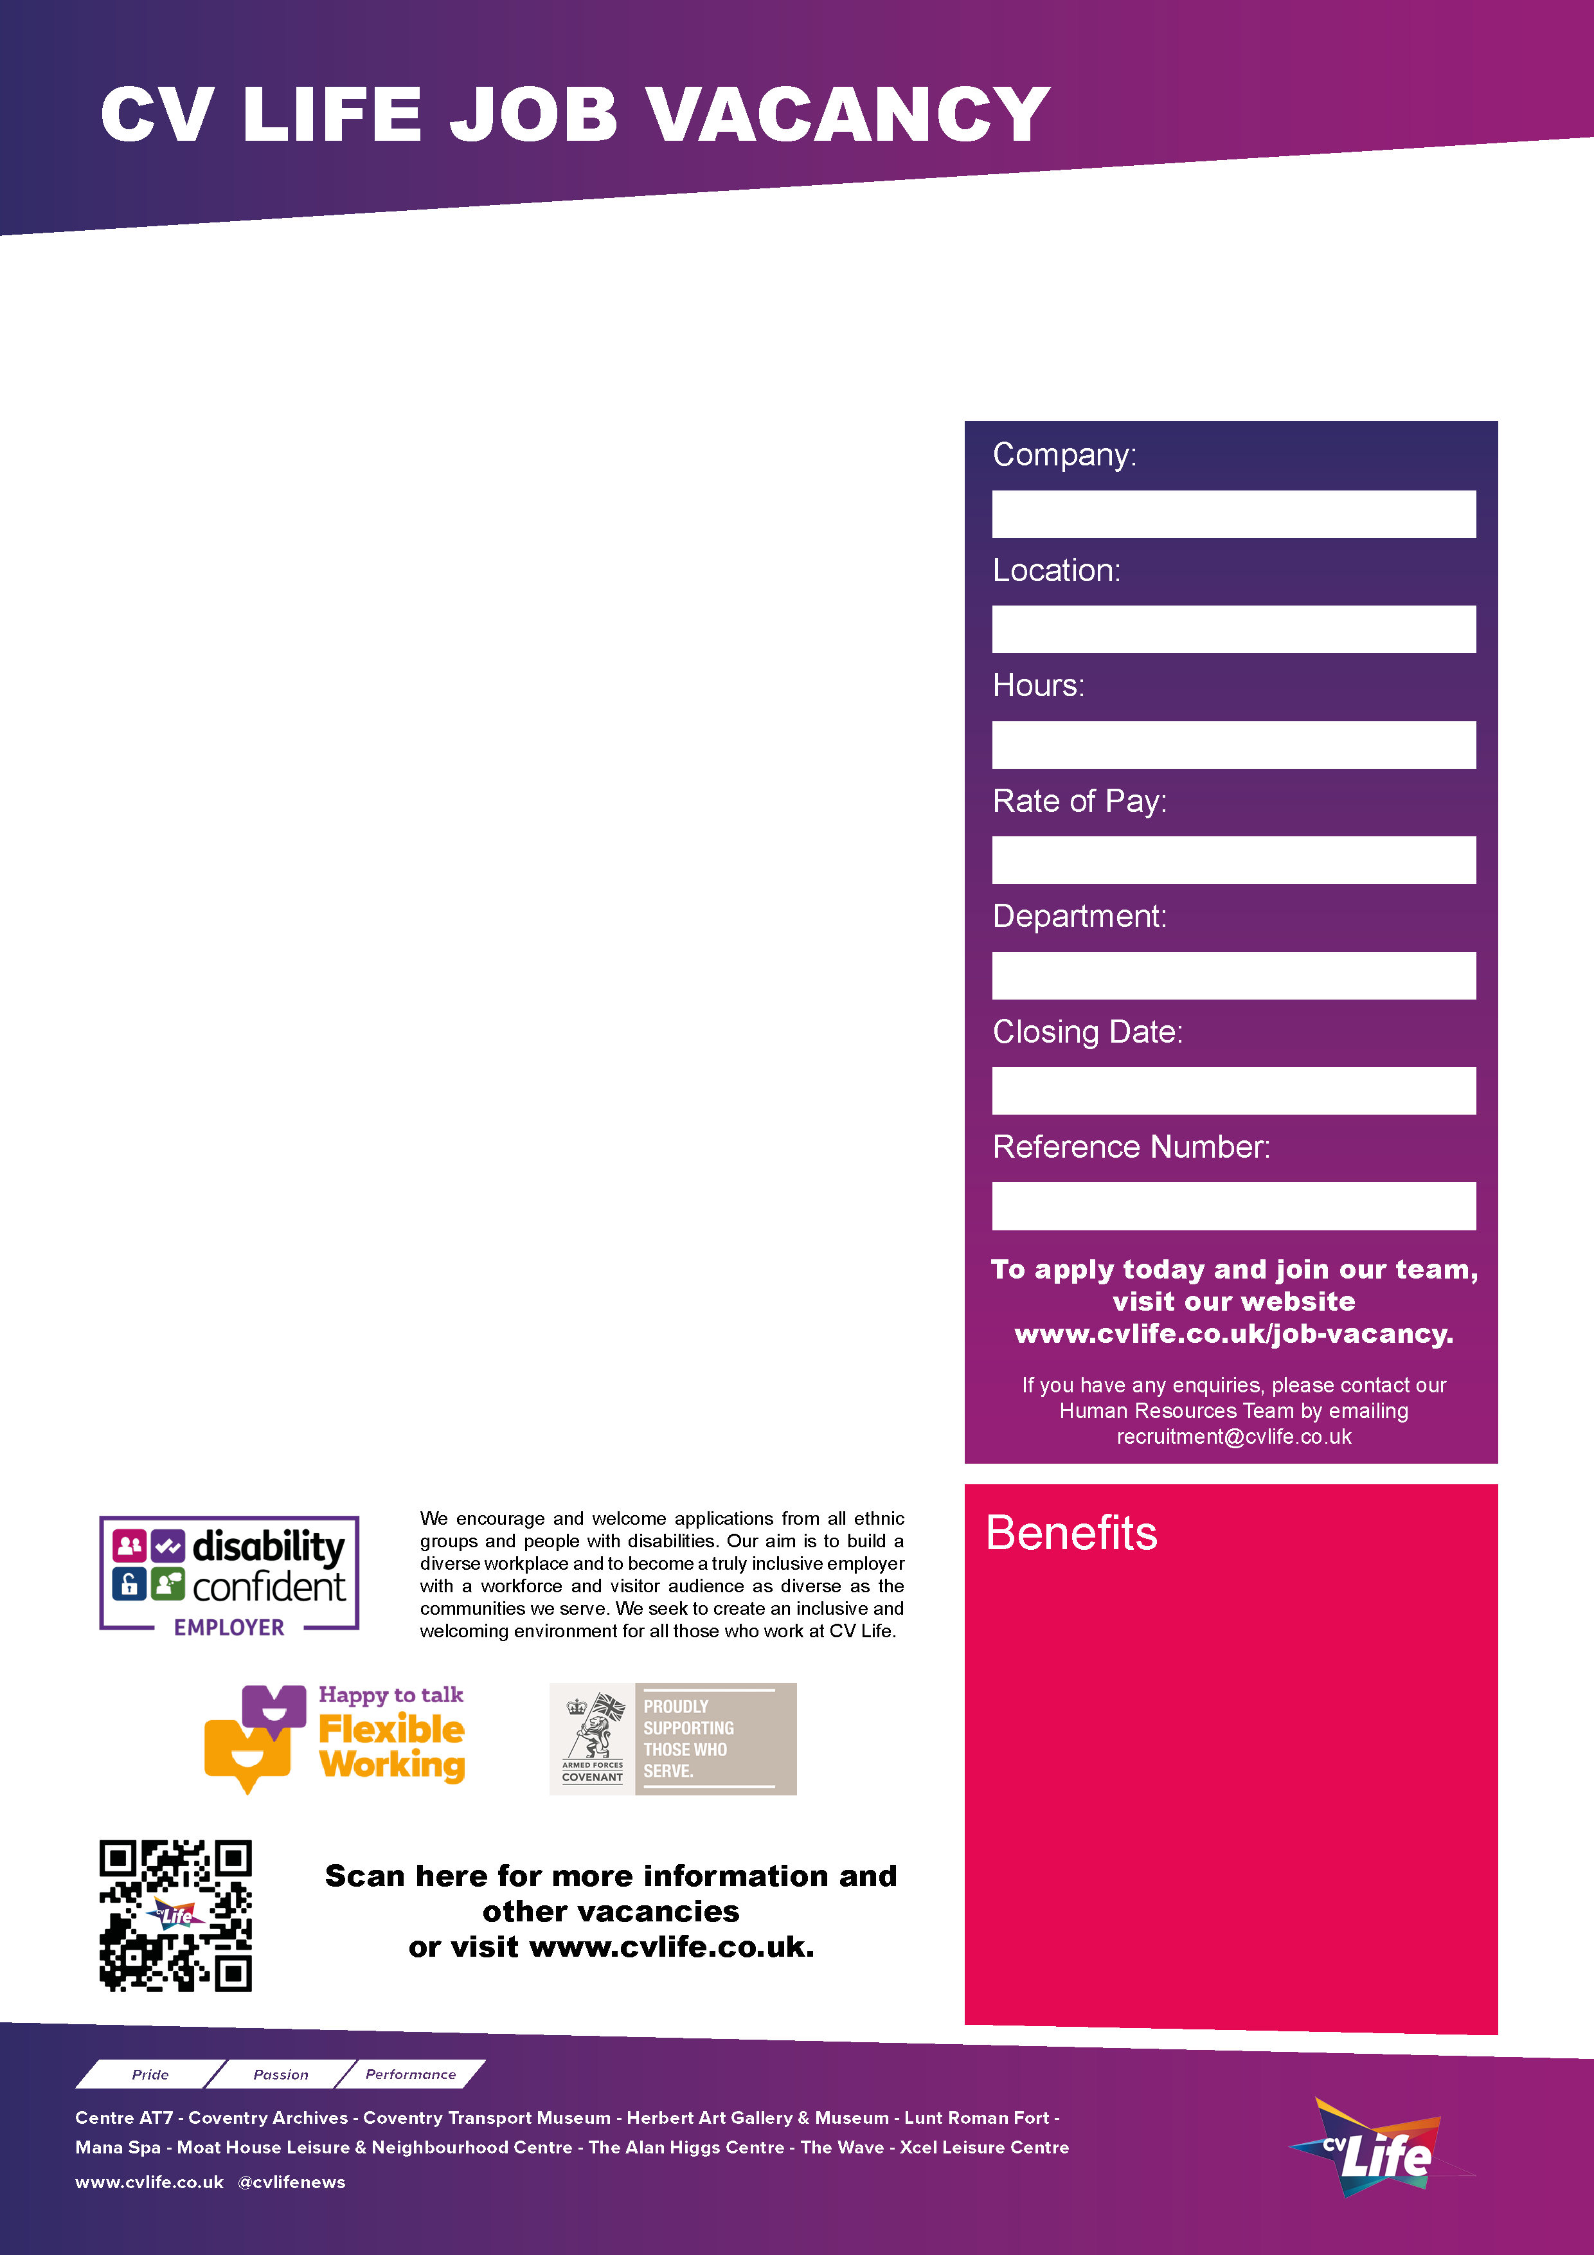

CV Life are seeking an experienced and detail-oriented Executive Support Officer to provide high-level admin support to the Executive Directorship team and Boards of Trustees.
Operating as CV Life, Coventry Sports Foundation and Culture Coventry Trust strive to make a real difference in the lives of local people by offering enriching experiences and opportunities, investing and working with and for our communities, and delivering through meaningful partnerships. We are looking for someone with a keen interest and dedication for making a difference to join our committed team.
The ideal candidate will play a pivotal role in ensuring clear communication and effective collaboration on key governance and strategic issues, governance compliance, monitoring funding activities, charity law compliance, and will provide strategic support to our Executive Directors.
Exceptional written and verbal skills and experience in office management are essential requirements of the role.

CV Life is committed to safeguarding and promoting the welfare of children and vulnerable adults and expects all staff and volunteers to share this commitment.
Executive Support Officer
- Great development opportunities
- FREE health and fitness membership* **
- FREE health and fitness membership for a family member or friend* **
- FREE onsite parking at most sites
- FREE training for applicable roles
- DISCOUNTS on various Centre activities*
- FREE entry to venues*
- Access to our Employee Benefits platform

( **The two benefits combined can be worth £1000!)
(*not applicable to casual workers)

XL253
31st July 2026
Executive Support
£30,900
37.5 Hours
Multi Site
Coventry Sports Foundation

