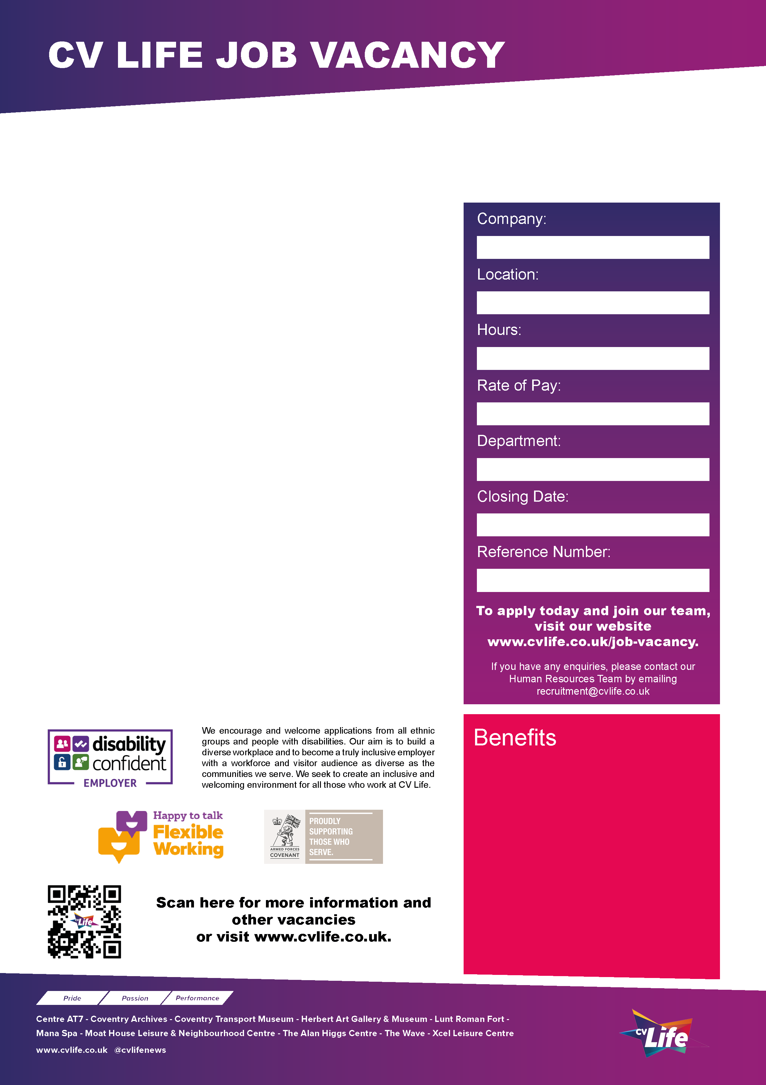
CV Life is seeking a Facilities Co-ordinator to support the Head of Facilities Management in the effective delivery of facilities management services across all CV Life sites within Coventry.

The role involves proactively supporting the management of a diverse portfolio of premises, ensuring all facilities consistently meet the organisation’s high standards and operational requirements.

You will oversee the upkeep and day-to-day maintenance of facilities, working closely with third-party service providers and internal CV Life teams.

Responsibilities include coordinating with external partners; the reactive and planned preventative maintenance activities across the portfolio, ensuring works are completed on schedule, overseeing urgent repairs within approved timescales and maintaining cost control in line with agreed budgets.

As Facilities Co-ordinator, you will take ownership of key areas of facilities management, including financial monitoring, record and data management, health and safety compliance, contractor management and supporting the organisation’s environmental sustainability objectives.

Working hours are 8:00-16:00 Mon-Fri (flexible working hours)

Apply Today and Join Our Team!

CV Life is committed to safeguarding and promoting the welfare of children and vulnerable adults and expects all staff and volunteers to share this commitment.
Facilities Coordinator
- Great development opportunities
- FREE health and fitness membership* **
- FREE health and fitness membership for a family member or friend* **
- FREE onsite parking at most sites
- FREE training for applicable roles
- DISCOUNTS on various Centre activities*
- FREE entry to venues*
- Access to our Employee Benefits platform

( **The two benefits combined can be worth £1000!)
(*not applicable to casual workers)

CCT084
24th February 2026
Estates
Up to £29,207.50 per annum
37 Hours
Multi-Site
Culture Coventry

