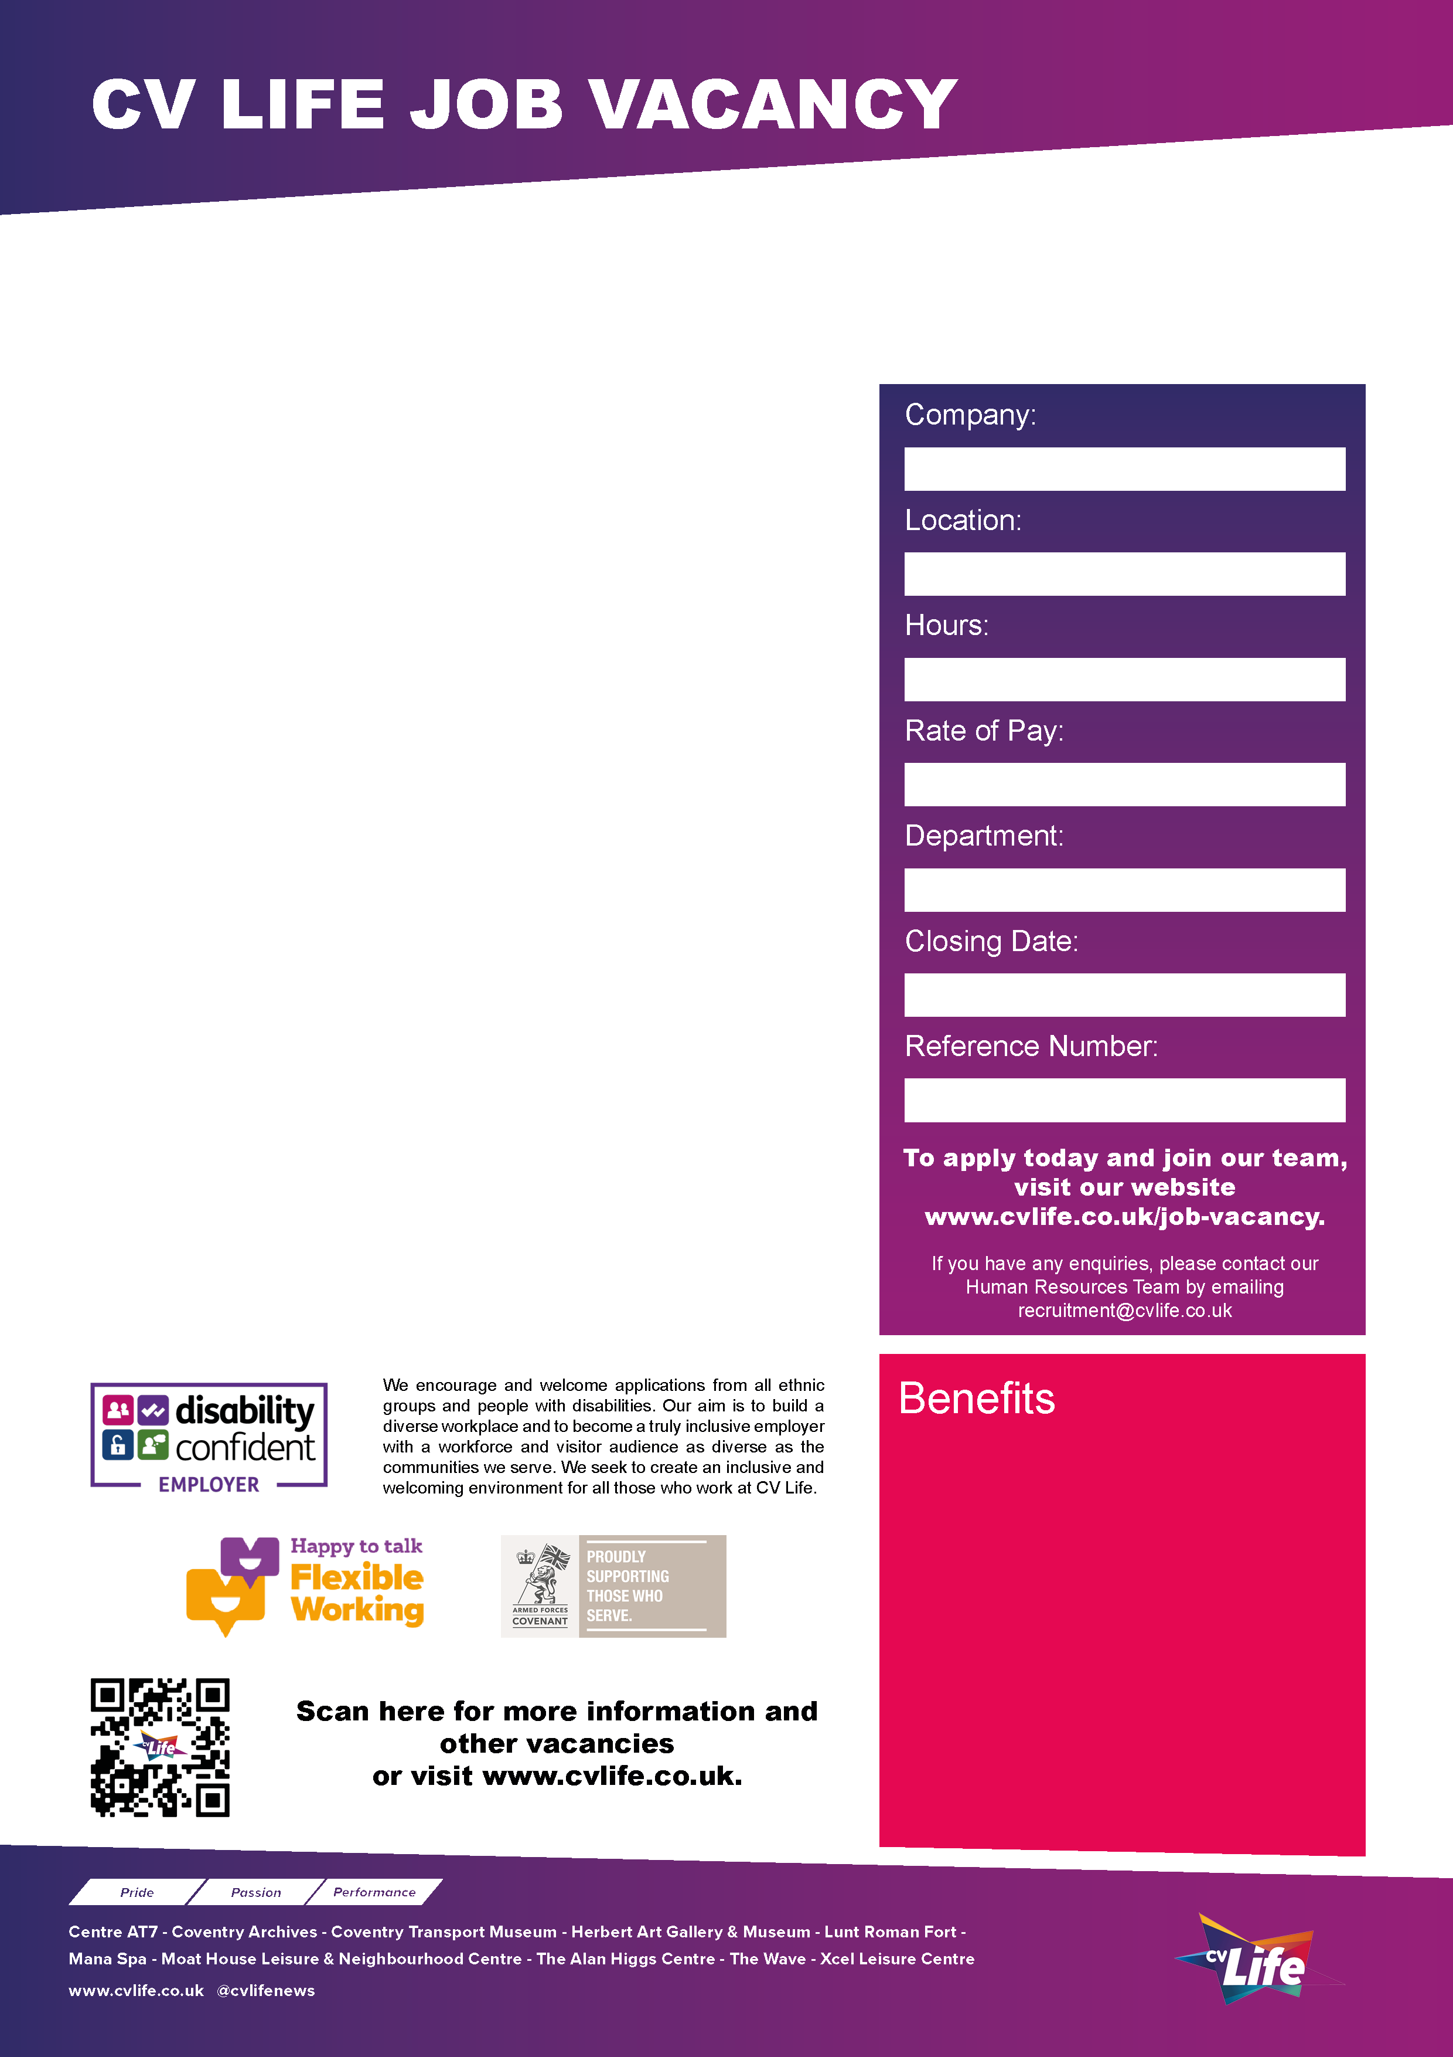
We are looking for a Facilities and Collections Access Assistant to support the move of Culture Coventry’s collections currently in off-site storage to a new Collections Centre in Coventry’s former Ikea building. Culture Coventry operates the Herbert Art Gallery & Museum and Coventry Transport Museum, as well as two off-site stores. Working as part of the busy Collections team, the role will involve supporting logistics and access around the preparation and movement of collections, supporting the day-to-day running and facilities management of our offsite collection stores and working with the Facilities and Collections teams to implement Health and Safety procedures required for working onsite. The main focus of the role will be at the store where the Transport and large Social and Industrial History collections are held however the postholder will have the opportunity to work across sites.

We are looking for a self-motivated team player with:
- Excellent planning and organizational skills
- Strong practical and manual handling skills, including ability to use lifting and moving equipment
- Knowledge of the health and safety considerations for working in a warehouse environment
- An interest in working with heritage collections

This is a 12 month contract, working 20 hours per week, Monday, Tuesday and Wednesday, start and finish times to be agreed.

Proposed interview date W/A 4th May 2026.
Apply today and join our team!
CV Life is committed to safeguarding and promoting the welfare of children and vulnerable adults and expects all staff and volunteers to share this commitment.
Facilities and Collections Access Assistant (Fixed Term)
- Great development opportunities
- FREE health and fitness membership* **
- FREE health and fitness membership for a family member or friend* **
- FREE onsite parking at most sites
- FREE training for applicable roles
- DISCOUNTS on various Centre activities*
- FREE entry to venues*
- Access to our Employee Benefits platform

( **The two benefits combined can be worth £1000!)
(*not applicable to casual workers)

CCT088
27th April 2026
Collections
NLW/NMW
20 Hours
Multi Site
Culture Coventry Trust

