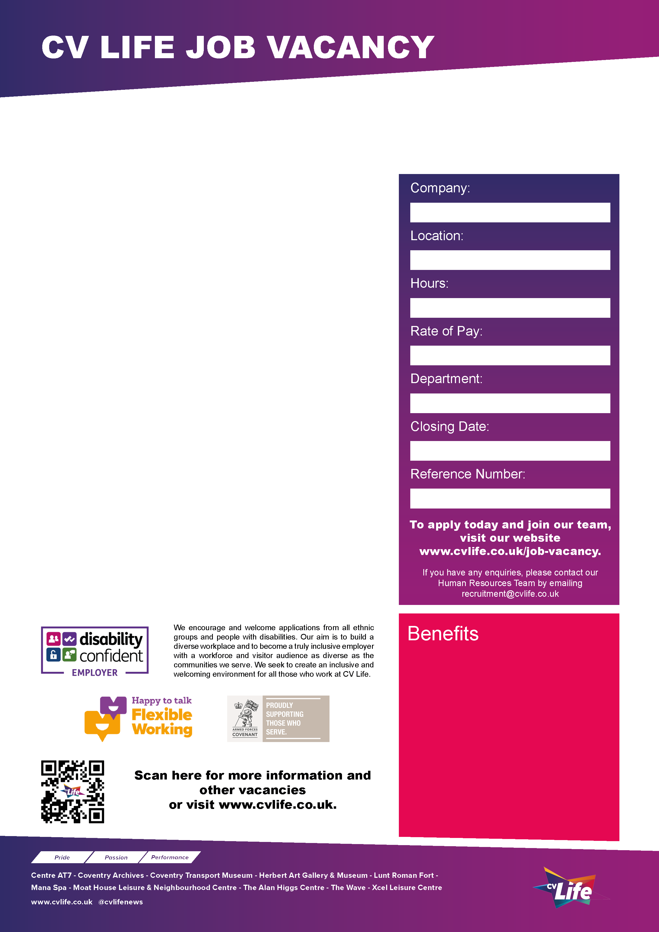
We are looking for an Archives Assistant to support the delivery and development of Coventry Archives as part of the wider Culture Coventry service, based at The Herbert Art Gallery and Museum in Coventry.

This is a fantastic opportunity to work within Coventry Archives on all aspects of archive and local studies library work. The role is based within the wonderful setting of The Herbert Art Gallery & Museum in Coventry. Reporting to the Archives Manager, you will assist in the day-to-day operation and collections management of the archives and local studies material. This customer facing role will help with the facilitation of access to the Coventry archive records, including any associated administrative activities to support the day to day operation of the archives.

This exciting role will give you the opportunity to develop your skills and build your professional experience, enabling you to develop a career in the heritage sector.

We are looking for candidates with:
- A strong interest in archives and local studies collections, with a good knowledge of the resources they offer.
- Excellent customer service when assisting customer enquiries.
- A helpful and welcoming approach to all archive users.
- Effective communication skills, with the ability to adapt your communication style when handling public enquiries.
- Good organisational skills to enable methodical working in accordance with procedures.
- A high level of attention to detail.
- A basic level of IT literacy to deliver day to day admin activities.
- An excellent standard of written and verbal communication.

Working hours:
10:30 –15.30 Tuesday, 10.00-15.30 Weds, Thurs & Friday.
Apply today and Join Our Team!

Proposed interviews to take place W/C 1st June 2026.

CV Life is committed to safeguarding and promoting the welfare of children and vulnerable adults and expects all staff and volunteers to share this commitment.
Archives Assistant
- Great development opportunities
- FREE health and fitness membership* **
- FREE health and fitness membership for a family member or friend* **
- FREE onsite parking at most sites
- FREE training for applicable roles
- DISCOUNTS on various Centre activities*
- FREE entry to venues*
- Access to our Employee Benefits platform

( **The two benefits combined can be worth £1000!)
(*not applicable to casual workers)

CCT092
18th May 2026
Archives
NLW/NMW
19.5 Hours
Herbert Art Gallery & Museum
Culture Coventry Trust

