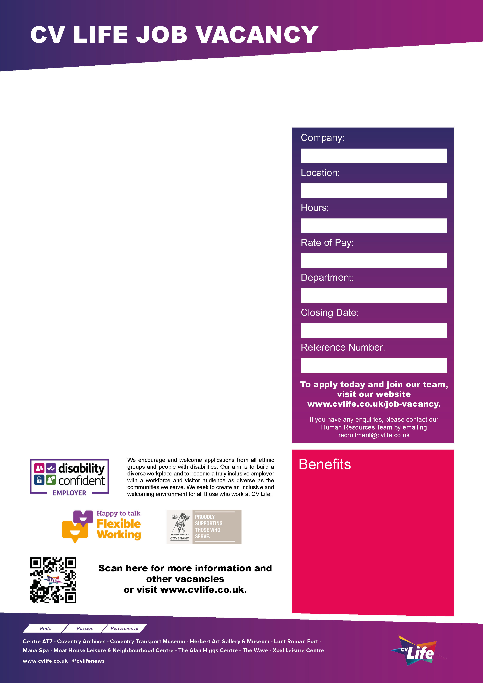
CV Life is committed to safeguarding and promoting the welfare of children and vulnerable adults and expects all staff and volunteers to share this commitment.

Are you an organised and inspiring programme manager with a passion for community engagement, education, and cultural learning? Do you enjoy leading teams, coordinating multiple projects, and ensuring high-quality delivery day to day?

We are looking for a proactive Learning and Engagement Manager to oversee the daily management and development of our education and community engagement programmes across CV Life’s cultural and venues.

This is a hands-on management role where you will lead operational delivery, manage staff and programme performance, coordinate projects and events, and ensure activities run smoothly, effectively, and to a high standard.

About the Role
Working closely with the Head of Learning and Engagement, you will manage the day-to-day operation of a varied portfolio of community and education programmes, ensuring they are engaging, commercially aware, and responsive to community needs.

You will oversee the planning, scheduling, delivery, and evaluation of activities across schools, families, and community audiences while supporting the continued growth of the service.

About You
You will be an experienced manager who is confident balancing strategic thinking with operational delivery. You will thrive in a fast-paced environment and be comfortable managing multiple projects, deadlines, and stakeholder relationships.

Additional Information
- Flexibility to work occasional evenings and weekends will be required
- Travel between sites is expected
DBS clearance will be required for the successful candidate.
Please visit our website for further details: www.cvlife.co.uk/dbs
Learning and Engagement Manager
- Great development opportunities
- FREE health and fitness membership* **
- FREE health and fitness membership for a family member or friend* **
- FREE onsite parking at most sites
- FREE training for applicable roles
- DISCOUNTS on various Centre activities*
- FREE entry to venues*
- Access to our Employee Benefits platform

( **The two benefits combined can be worth £1000!)
(*not applicable to casual workers)

CCT093
21st June 2026
Learning and Engagement
£28,940.21 to £35,687.63
37 Hours
Multiple Sites
Culture Coventry Trust

