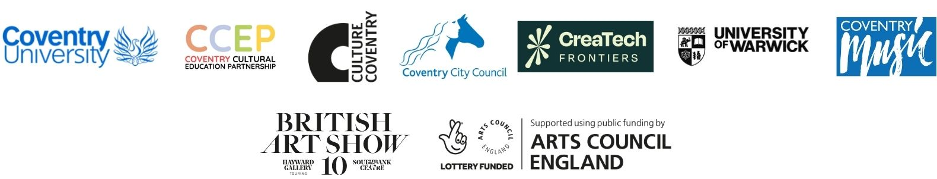

Culture Coventry Artist Callout

Background Information
The Herbert Art Gallery & Museum (part of Culture Coventry) will be a host venue for British Art Show 10, from 1 October 2026 - 10 January 2027, along with Coventry University and the Mead Gallery, University of Warwick.
Held every five years, the British Art Show is the largest and most significant recurring exhibition of contemporary art in the UK. It is managed by Hayward Touring, South Bank Centre, London.
The tenth edition of British Art Show is curated by Ekow Eshun and is entitled ‘A Chorus of Strangers’. It will tour to five cities across the UK, and Coventry is the opening venue for the show.
The themes of the show reflect how society is shaped by social division, climate uncertainty and political tension, exploring how art can help us imagine empathy, connection and shared futures.
Thanks to funding from Arts Council England through the Shape Coventry programme Shape Coventry | Coventry University we're offering three artist commissions linked to the British Art Show in Coventry. The aim is to help more young people connect with and experience the exhibition in meaningful and creative way.

The Brief
We are commissioning 3 artists to create work in any visual arts medium:
- 1 artist will work with a group from a local mainstream school
- 1 artist will work with a local SEND school

- 1 artist will work with a home educator group
The outcome will be new artwork, co-produced with young people, which will feature as part of Culture Coventry’s creative programme linked to British Art Show 10.

Successful artists will be paid £10,000 (including VAT) per commission to include:

- A minimum of 3 in-person workshops delivered with young people
- All materials
- Planning and development time
We also have an access budget available to help remove barriers and support artists with any access requirements.

Further Information about the Brief

- We are looking for artists to work with three cohorts, including one mainstream school, one SEND school and Culture Coventry’s Home Educator group
- Artists must be living or working within a CV postcode, have a link to the city or be able to demonstrate that they work regularly in Coventry
- The aim of the commission is to support young people to:
- Enhance their art skills
- Open up new opportunities for their creative futures
- Access resources that they are unlikely to have at home
- Learn and be inspired by working artists
- Connect to British Art Show 10 through creative means
- Workshops will be held during the autumn term with dates to be agreed in consultation with the artist and the schools
- The final commission will ideally be presented during the period that BAS10 is in Coventry but could extend into the legacy period of the show
- You are welcome to submit multiple applications if you are interested in delivering one or more commission
- Workshops should take place in the relevant educational setting during the school day 9.00am-3.00pm
- You will be supported by teachers/learning facilitators who will lead on coordination, welcoming children, lunches, management of behaviour and supporting children where additional care is required
- We do expect you to be comfortable and confident in delivering activities to children aged between 7-11 years
- Workshop sessions will have a maximum size of 32 students
- Artists would ideally have an existing enhanced DBS clearance and their own Public Liability Insurance

Application Form

Things you need to include in your application:

- Some details about yourself

- Your creative idea - how you would work and what you would do

- Which education group you want to work with, and why?

- What support needs you have, and how best to communicate with you

- Your contacts details – Name, email address, telephone number, postal address

You can submit your application in different ways:

- In writing, telling us about you and your ideas

- A sound recording about you and your ideas

- A video recording about you and your ideas

- A set of images describing you and your ideas

- Or a combination of any of these

These should ideally be sent to us via an email or social media message with a hyperlink and/or a file or document attachment. You can also post your application to us but we cannot guarantee to return items sent to us this way.

SEND EMAIL TO: Cvlifelearning@cvlife.co.uk
POSTAL ADDRESS: The Herbert Art Gallery & Museum, Jordan Well, Coventry, CV1 5QP

Application Form – Guidelines and Timeframe

As a guide only we would suggest a maximum of 500 words of text, or 7-8 minutes of sound or video or 30 images.

CLOSING DATE FOR APPLICATIONS: Monday 31 August 2026, 4:00pm

Interviews with shortlisted artists will take place in the week commencing 7th September 2026.

If you have not heard from us by the 14th September you have been unsuccessful in this application

Shortlisted artists will be asked to give a outline of how they will allocate grant funds (budget) and when the work will happen (timeline for delivery)

If you require any further information or support to complete this application please contact: Marguerite Nugent Mknugent@cvlife.co.uk

